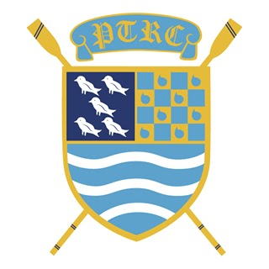

PTRC 100 Club Membership Application Form
Organiser : Mary Mortimer, ℅ PTRC, Kew Meadows Path, Kew, Richmond, TW9 4EN

To join the PTRC 100 Club, please complete and return this form to Mary Mortimer at 100club@putneytownrc.co.uk

I wish to join the PTRC 100 Club and I would like to pay the following monthly subscription :

1 number @ £5 per month …………………..
2 numbers @ £10 per month ………………..
3 numbers @ £15 per month ………………..
Other amount …………………

I have set up a monthly Standing Order to PTRC to commence within the first week of the month and my reference includes 100surname/numbers purchased (ie. 100mortimer2) :

A/C Name : Putney Town Rowing Club
Account No. : 33132382
Sort Code : 20-72-33

Name : ………………………………………………………………………………………

Address : ……………………………………………………………………………………

Mobile : ……………………………….

Email : ……………………………………………………………

Signature* : …………………………………….
(* by signing you confirm you are happy to have your name published should you be a lucky prize winner. You can request to remain anonymous at any time.)

Please email to 100club@putneytownrc.co.uk to confirm that you have set up a standing order.

Office Use Only
100 Club Numbers

Putney Town Rowing Club is registered as a Small Society Lottery No. 830

